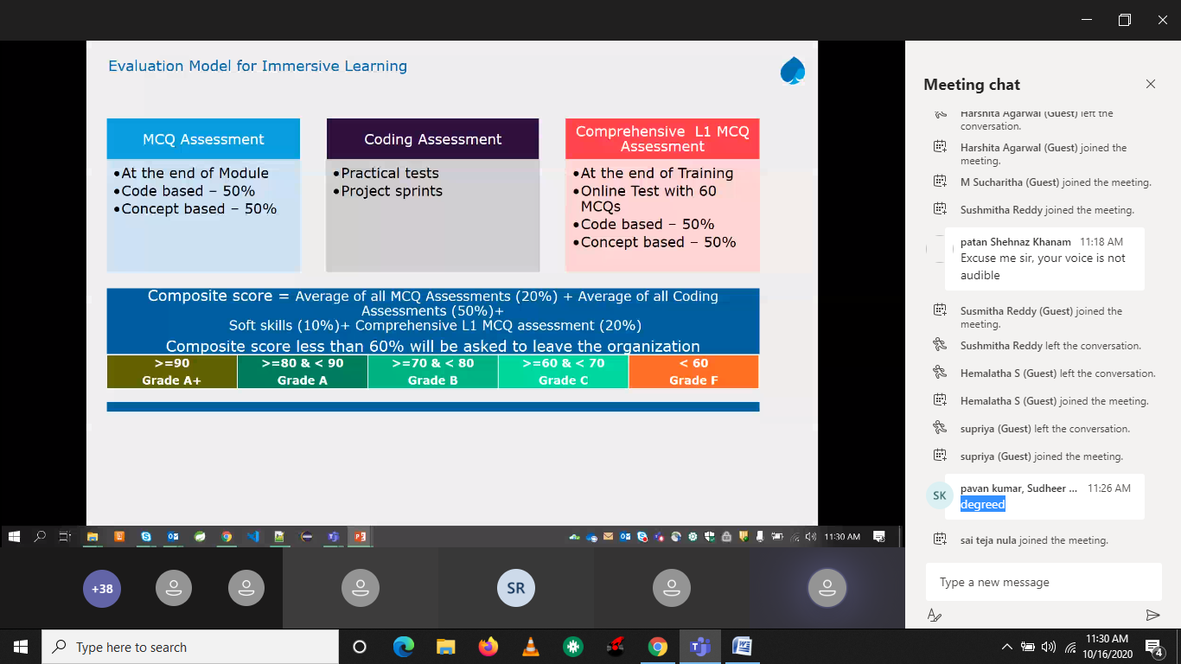

1programming test

3 mcq test

2projects(2sprint test)

L1 30 coding based 30 (60mcq)

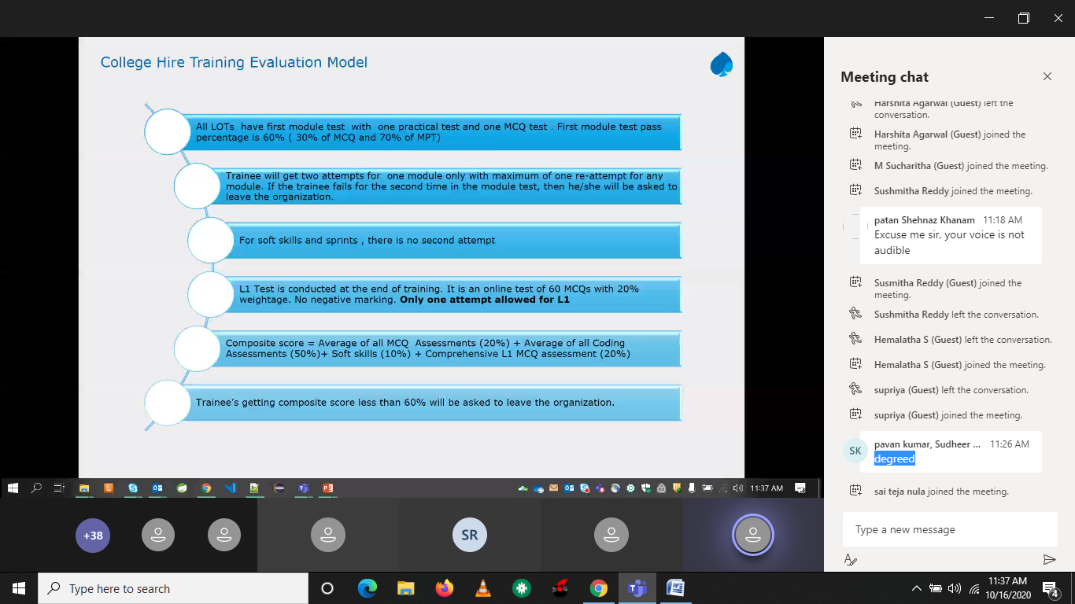

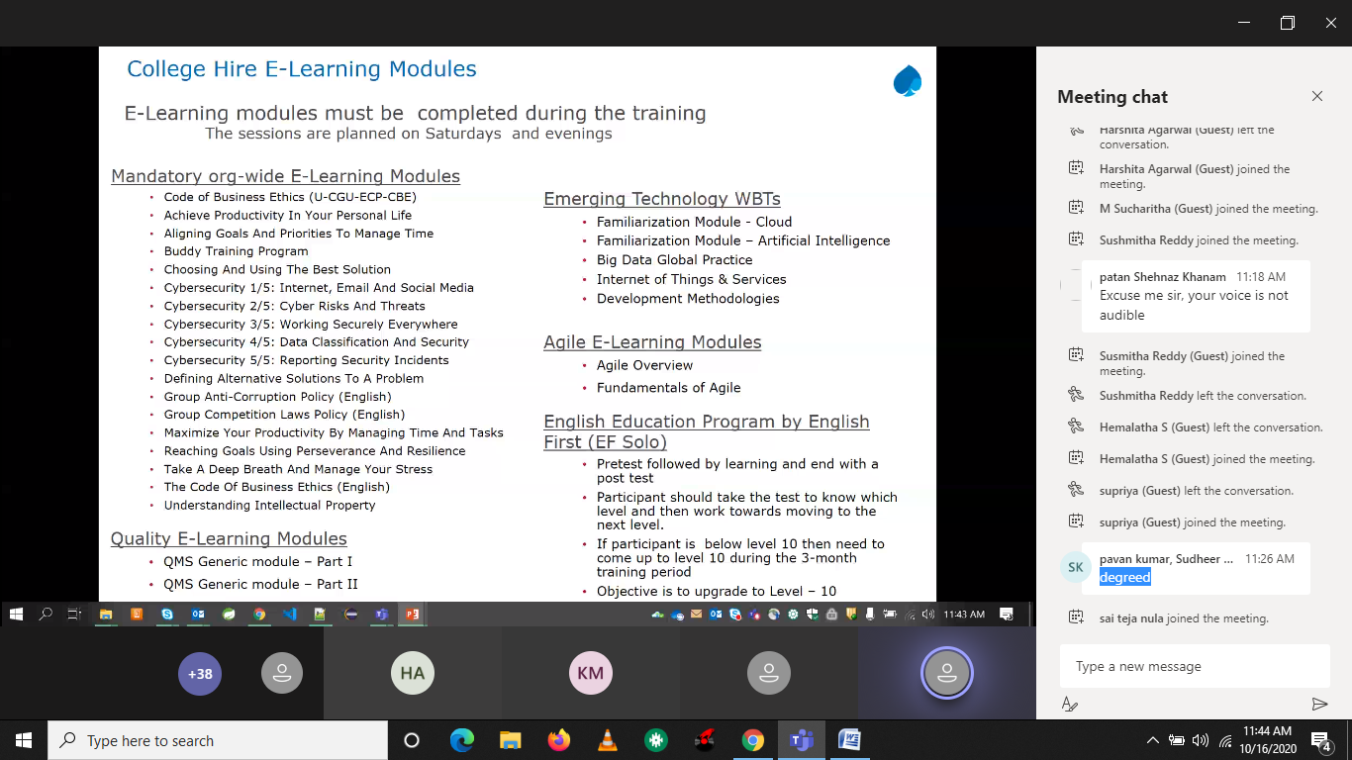

Need to complete

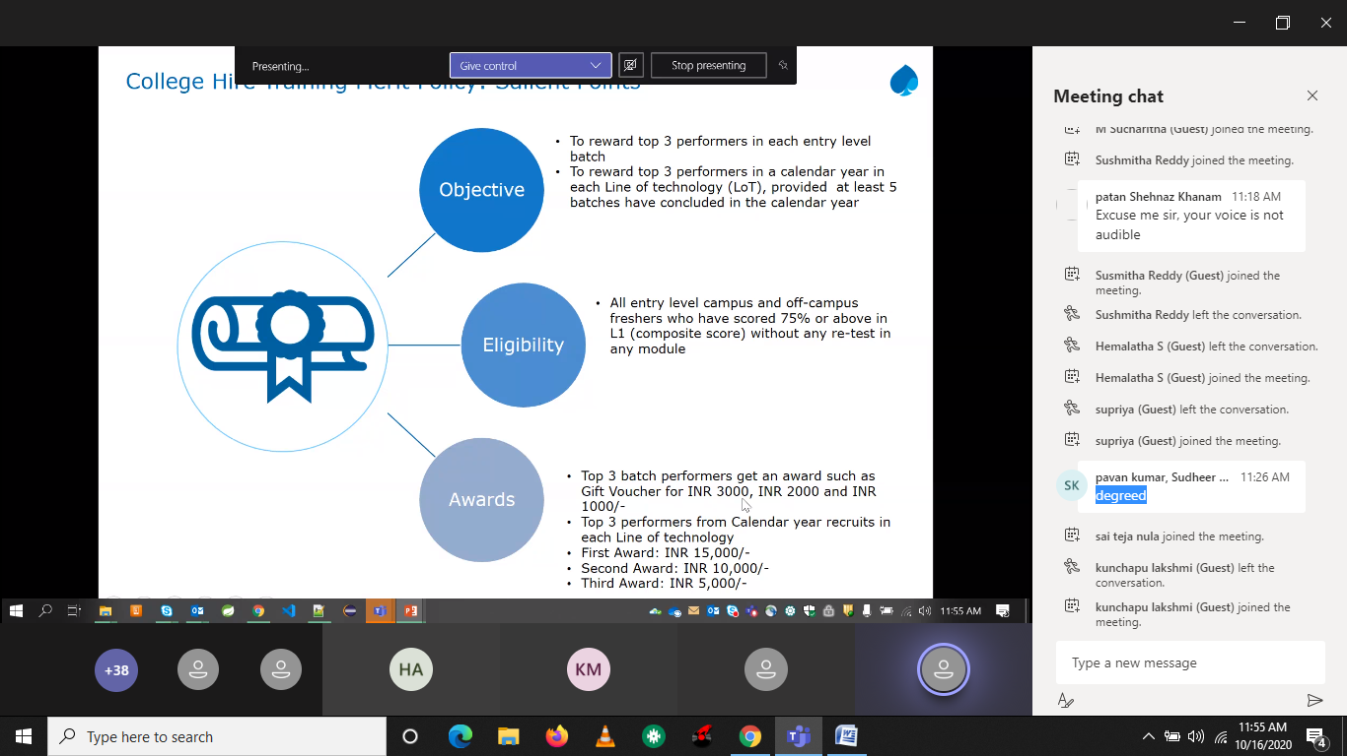

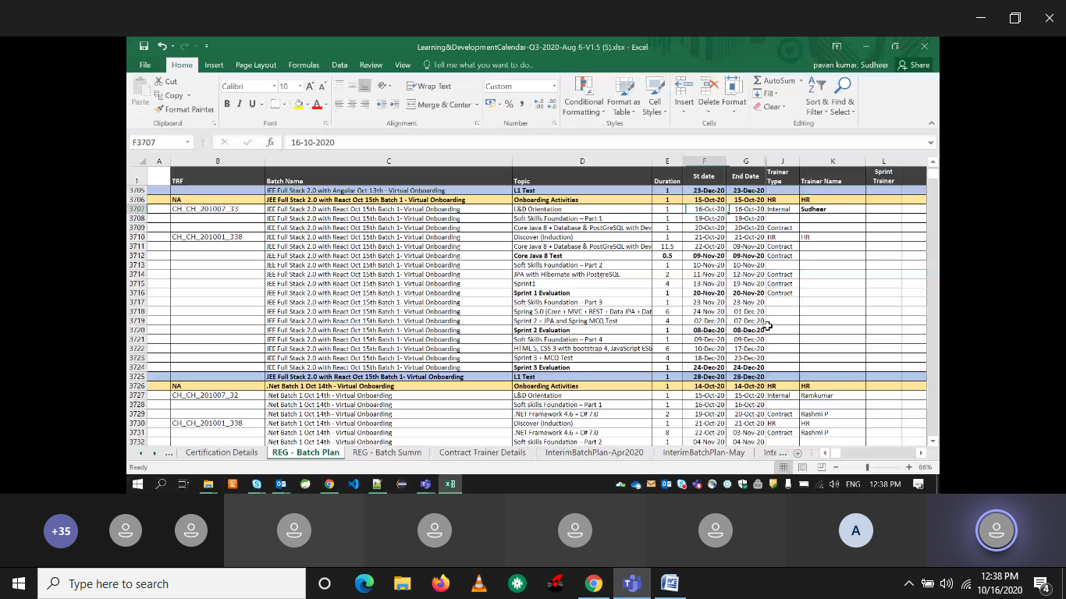

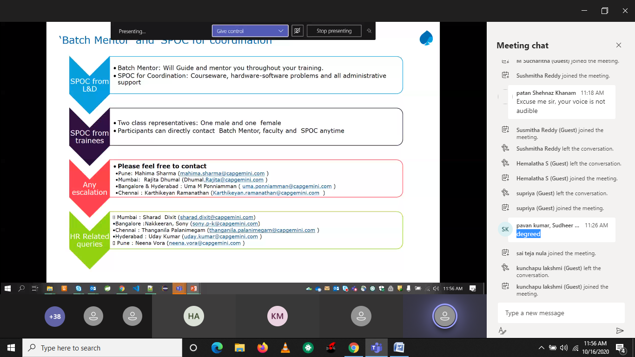

Softskill supriti

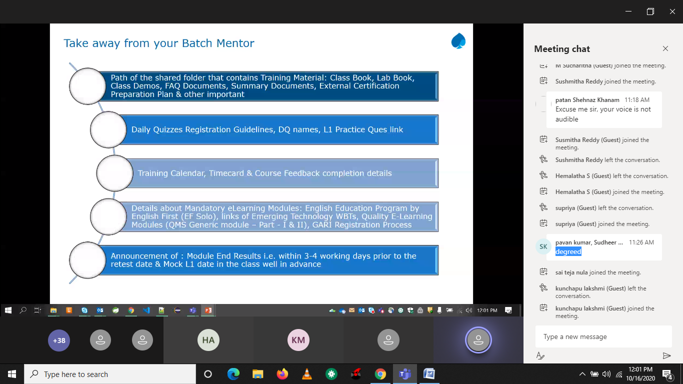

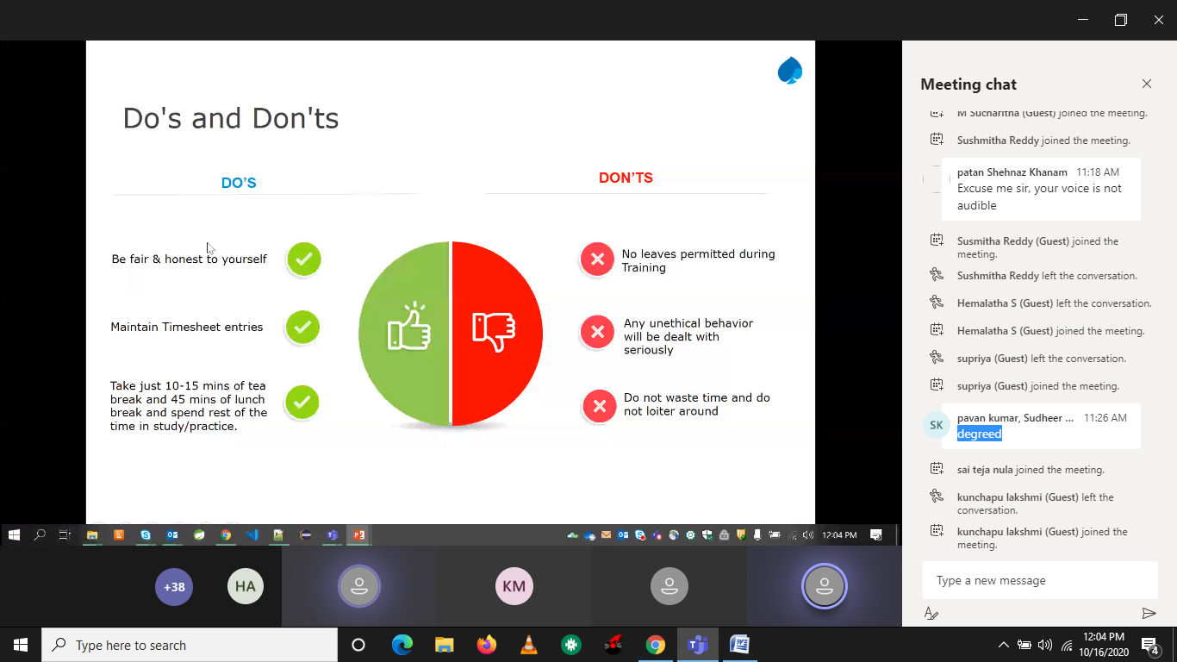

Java 8

Ecplise (Neon)

postgreSQL

<https://www.postgresqltutorial.com/install-postgresql/>

talent.capgemini.com/in

<https://talent.capgemini.com/in>

🡪next

🡪leave management system

🡪myconnect

🡪Timecard🡪finance🡪timecard summary

100249731(project code)

9.5

9.5…

🡪my learning

🡪Empulse

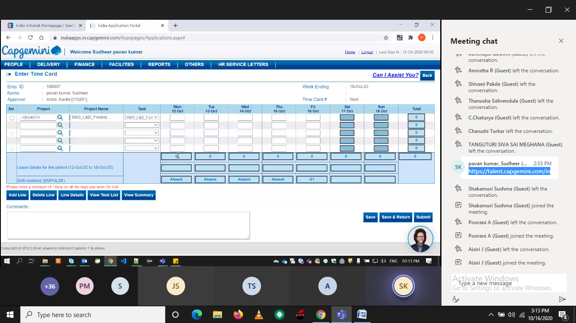

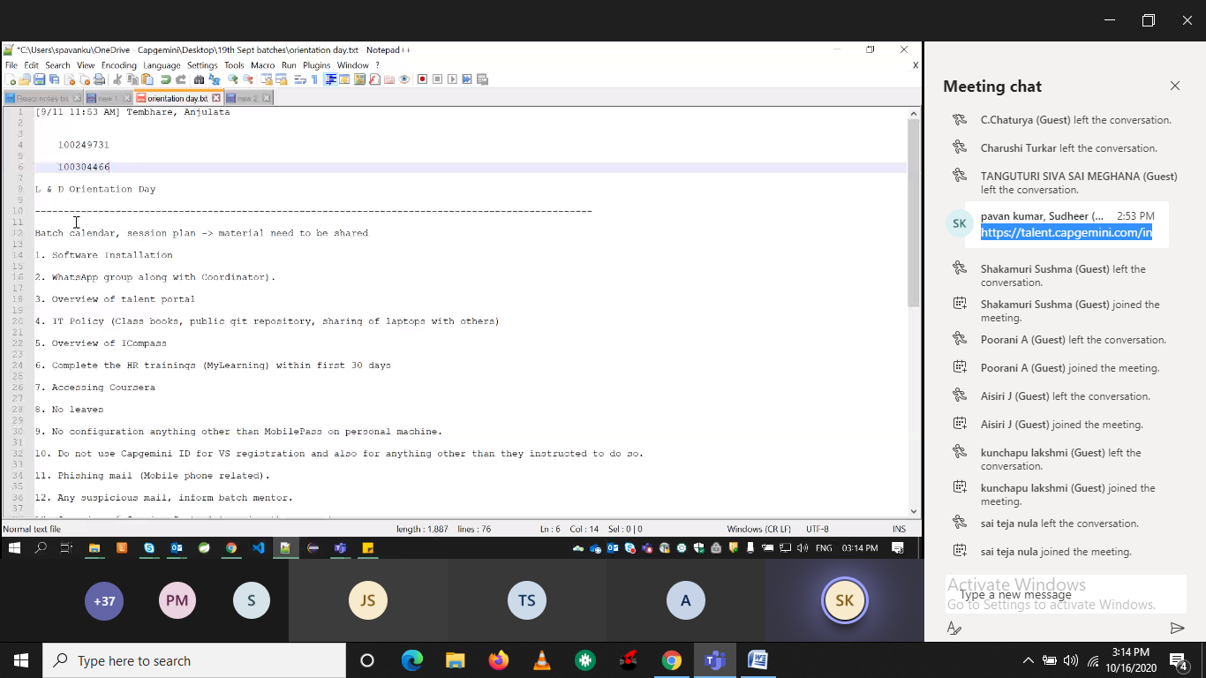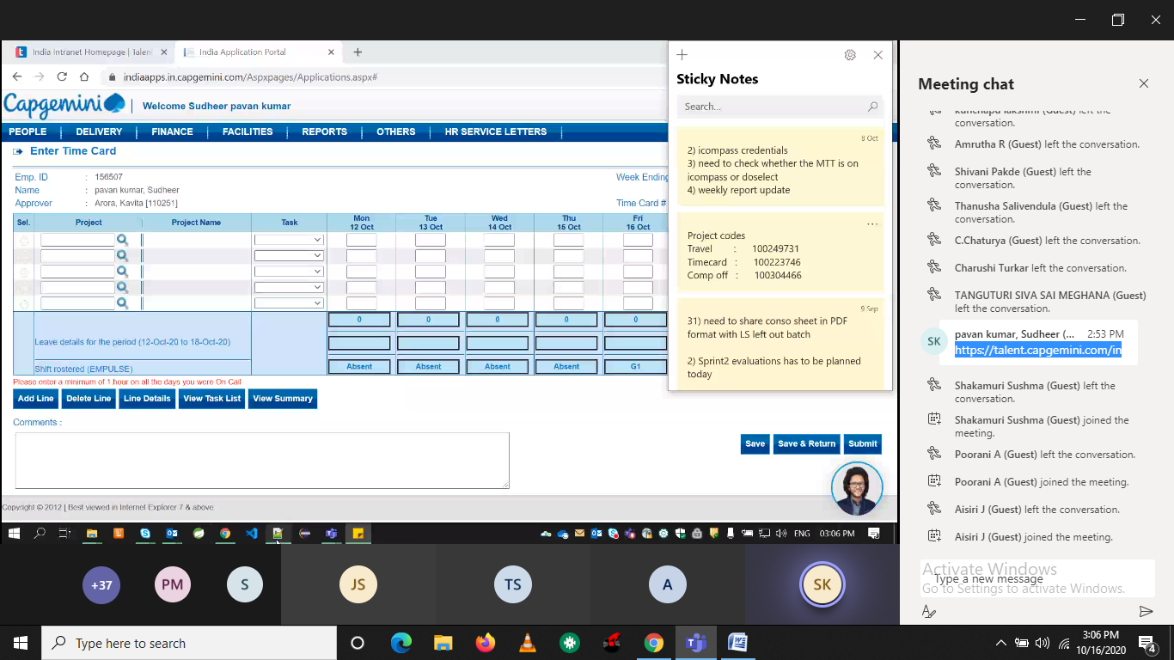

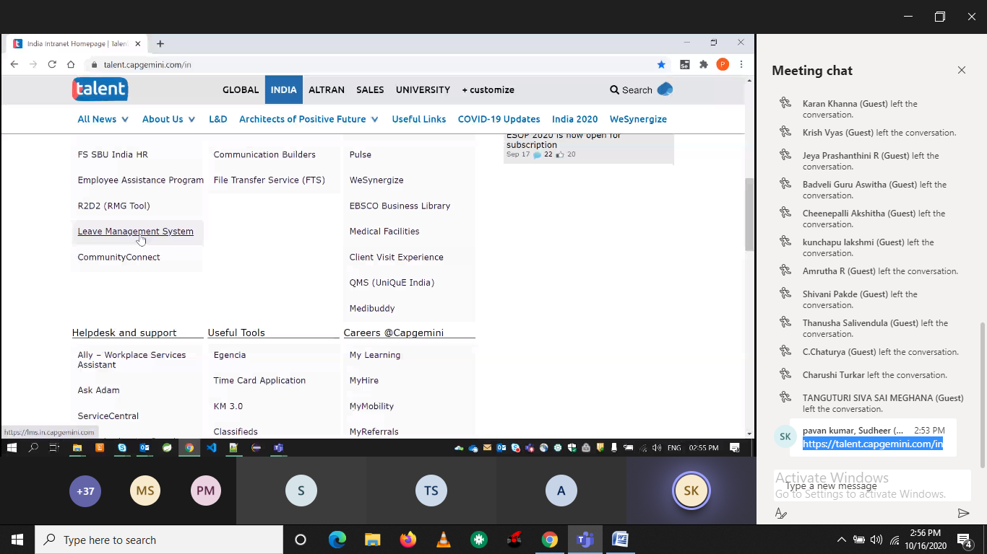

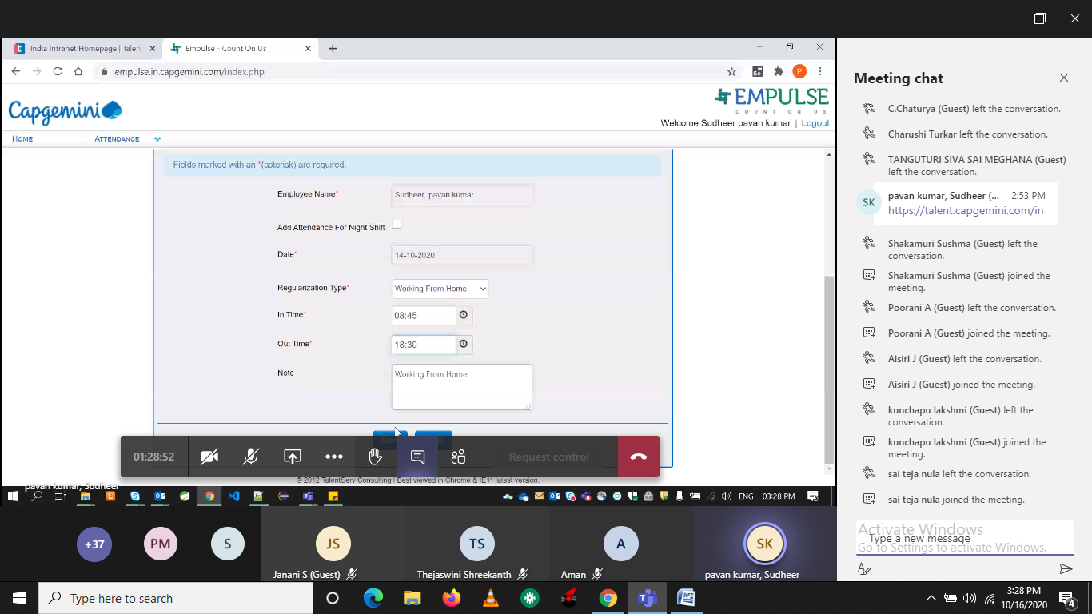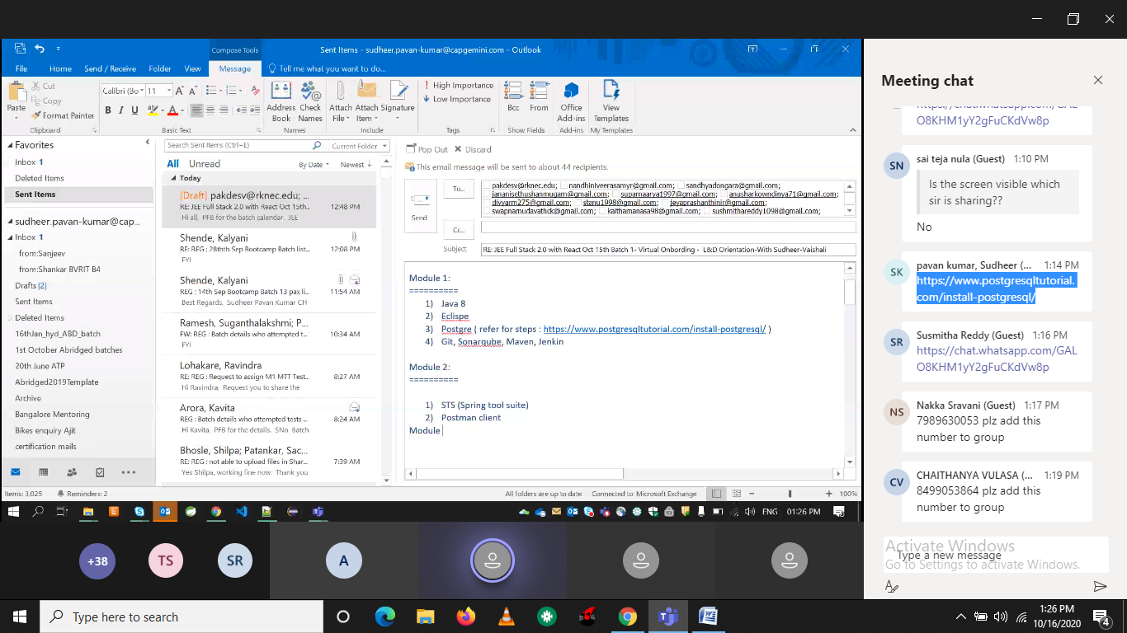

Daily quiz:

<https://icompassweb.fs.capgemini.com/iCompass/#/>

coursera🡪agile (Praveen meethaal)

paavan

9533359076